**Simulation report**

3.1) The listed below signals should be presented in the screen capture you need to attach to

your report. Show clock cycles 196-224 (following the end of the reset pulse, find i=196-224)

and make the values of all signals readable. For this you will probably need to show clocks

196-210 and 210-224 separately. These are the signals that can help you in “testing” the

DMem.

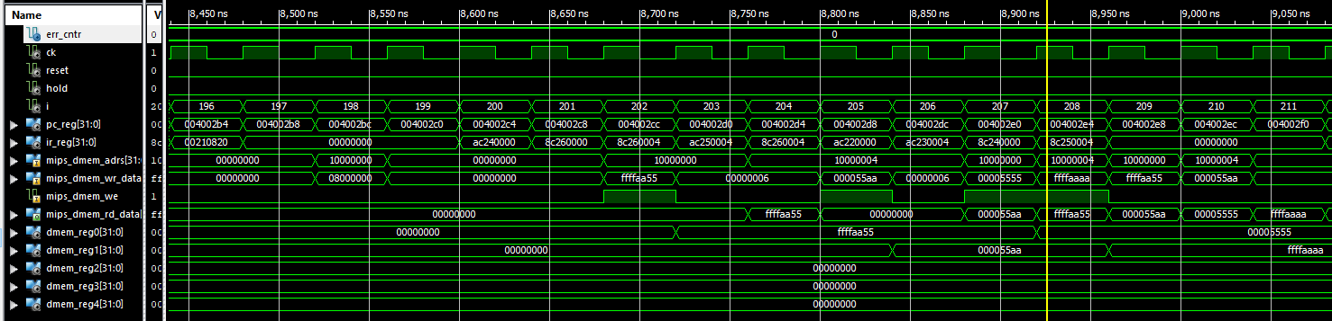

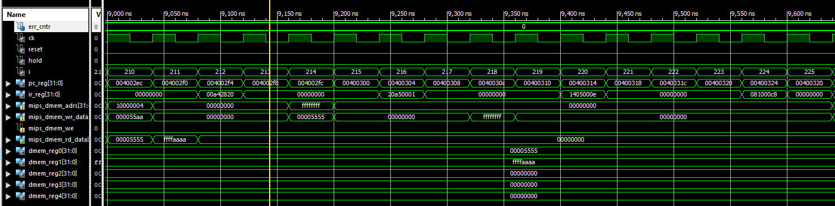

3.2) Explain in detail what happens, i.e., what do we see here. Note that it is essential to the

success of your future design that you will verify that the design does what we wanted it to

do in these CK cycles.

3.3) What is the latency of an R-type instruction? That is: How many nop-s should be inserted

between two consecutive R-type instructions if the 2nd one uses the result of the 1st one?

**There should be 3 nop-s between two consecutive R-type instructions. i.e., the latency of a R-type instruction is 3 CK cycles.**

3.4) Explain the limitation of beq that tests a register that is calculated by Rtype instruction.

As an example, translate the following C if statement:

for (i=0;i<10;i++) { … }

where i resides in register $3.

3.5) Are there any other limitations due to the pipeline structure in the instructions we

implemented (Rtype, addi, beq, bne, lw, sw, j)? How can we overcome these limitations

(e.g., by adding nop-s)? Try to list all of the **SW** & **HW** based solutions you can think of.

**Implementation report**

1. What is the value of register $2 after 122 cks?
2. What happens after 126 CKs?
3. What happens when you press the RUN button?  
     
   a rectangle has been drawn on the screen.
4. Explain the **HW5_rect4** program (what is the job of every register used. What is done in each loop, etc.)  
     
   The main aim of the program is to draw a rectangle to the screen. It do that by:  
     
   Register $1 saves the number of lines of the rectangle that will be drawn.  
   Register $2 is the addresses pointer.  
   Register $3   
   Register $4 is the loop counter.  
     
   label shft_lp: does 16 times shift left  
   label drawlp: write to screen the rectangle.   
   label end: end program. An endless loop.
5. How long does it take [in seconds] to draw a 32x32 white square when we use the draw loop of the **HW5_rect4** program?
6. Can you shorten the loop? If you can, write the code and explain.
7. Can you think of a faster way to draw the square in the same short loop? If you can, write the code and explain.